*IPL Data Ball by Ball*

**Dashboard 1 🡪 Batsman Run In IPL**

1] As per IPL data ball by ball I can easily identify total no. of over, total no. of wicket.

2} In this dashboard I represent Batsman Run in IPL.

3} In this dashboard you can easily filler data as per Batsman.

4} In this Dashboard I used Pie chart to show batsman run by innings wise.

5} I also represent data innings 1 by stacked column and 2nd innings with line.

Below are the data which is use in dashboard

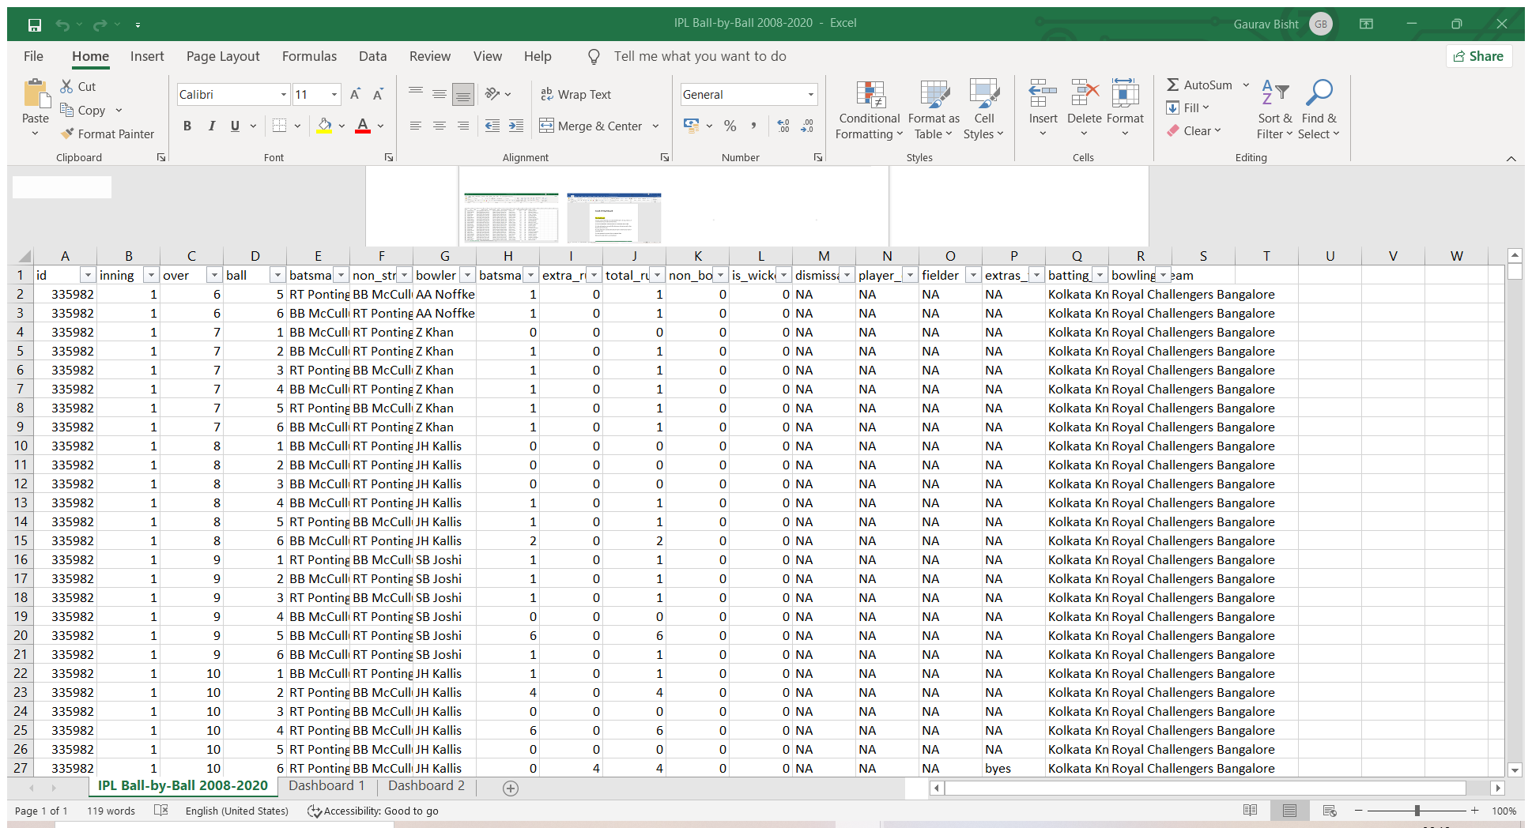

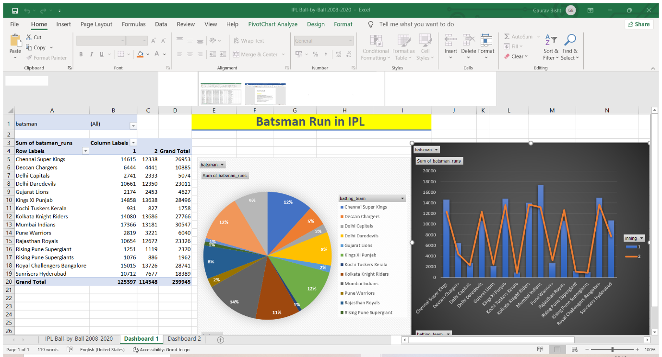

**Dashboard 2🡪 Bowler Wicket In IPL**

1] As per IPL data ball by ball I can easily identify total no. of over, total no. of wicket.

2} In this dashboard I represent Bowler wicket in IPL.

3} In this dashboard you can easily filler data as per Bowler.

4} In this Dashboard I used Pie chart to show bowler wicket by innings wise.

5} I also represent data innings 1 by stacked column and 2nd innings with line.’

6} I used insert slicer for dismissal kind.

Below are the data which is use in dashboard



